**Chapter 09-03: Integrated Processes**

|  |
| --- |
|  |

|  |
| --- |
| **PRODUCT**  SAP S/4 HANA 1709 |
|  |
| **REVISED**  04/25/2020 |
|  |
| **FOCUS**  Procurement  Fulfillment  Production  MRP |
|  |
| **AUTHORS**  Simha R. Magal  Jeff Word |
| **VERSION**  1.3MCC  **TESTED**  Date: 04/26/2020  System: |

|  |
| --- |
| **MOTIVATION**  In this exercise, you will do the following for Integrated Processes:   1. Create Appropriate Master Data 2. Begin Fulfillment Process 3. Begin Procurement Process 4. Production Process 5. End Procurement Process 6. End Fulfillment Process |

|  |
| --- |
| **ACKNOWLEDGEMENT**  These are the GBI exercises developed by Simha R. Magal and Jeff Word.  These exercises include concepts discussed in the book, *Integrated Business Processes with ERP Systems* (Epistemy Press, 2012). |

|  |
| --- |
| **PREREQUISITES**   1. You should be familiar with navigation in SAP ERP 2. Completed Exercises Chs. 02-01 through 08-02 |



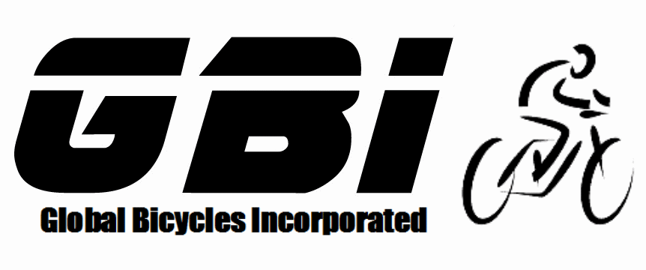

© 2020 Epistemy Press, LLC.

Screenshots © 2020, SAP SE

1. Table of Contents

Table of Contents

Section 1.1: Create Appropriate Master Data **Error! Bookmark not defined.**

Section 1.2: Begin Fulfillment Process 5

Section 1.3: Begin Procurement Process 6

Section 1.4: Production Process 11

Section 1.5: End Procurement Process 12

Section 1.6: End Fulfillment Process 13

* 1. Create Appropriate Master Data

The purpose of the chapter 9 exercises is to bring together everything you have learned throughout the course. There will be very limited instructions provided as you should be referencing previous exercises whenever you are unsure of what to do. You will be required to do more than what is specifically stated in the exercise.

* Before you start the entire cycle, you need to create the following master data beforehand. Notice that some master data is already created in the system from the previous exercises.
* **FIRST:** Before you begin any process for the assignment it is VITAL inventory be cleared out. You may use movement type 562 in transaction code MB1C or complete the fulfilment process. You only need to clear out your Dallas and Miami Plants. You will need to clear out inventory for your Off-Road Helmets, Deluxe Touring Bikes (Silver), Touring Wheel Aluminium Wheel Assembly and all Raw Materials.
* Copy from the original Spy Gear vendor to create your own Spy Gear vendor.
* You need to copy from the original Beantown Bikes customer to create your own customer.
  + You will need to create this customer twice.
    - 1) Create the customer using your East Sales Organization, the Wholesale Distribution Channel, and Bicycles Division.
    - 2) Create this customer using your East Sales Organization, the Wholesale Distribution Channel, and Accessories Division.
  + Use Miami as the delivering plant.
* Copy from the Original Off-Road Helmets Trading Goods to create your own trading good.
  + Create the trading goods using views
    - Basic Data 1
    - Sales: Sales Org. Data 1
    - Sales: General/Plant Data
    - Purchasing
    - MRP 1
    - Accounting 1
  + Within Miami, using your East Sales Organization and Wholesale Distribution channel
  + Use Miami as the Delivering Plant
  + Use Your Purchasing Group
* Copy from the Original Deluxe Touring Bike (Silver) finished good to create your own finished good.
  + Create the finished good using views:
    - Basic Data 1
    - Sales: Sales Org. Data 1
    - Sales: General/Plant Data
    - MRP 1
      * Remember to create this material using the appropriate MRP type.
    - Accounting 1
  + Within Miami.
  + Use your East Sales Organization, and Wholesale Distribution.
  + Use Miami as the Delivering Plant
* Create pricing conditions for your Deluxe Touring Bike (Silver) and Off-Road Helmet.
  + Price Your Deluxe Touring Bike (Silver) at 2800 for your US East Sales Organization.
  + Price Your Off-Road Helmet at 50 for your US East Sales Organization.
  1. Begin Fulfillment Process

In this section, you received a Purchase Order from Beantown Bikes for Five Deluxe Touring Bikes (Silver) and Fifty Off-Road Helmets in Miami. The Purchase Order Number from the vendor is 0##-43660. You will begin fulfilling this order by creating a quotation. It may help you to refresh your memory that within GBI US, although you have previously fulfilled from Miami, Miami buys and sells while Dallas produces.

* The Sales Quotation will be using the East Sales Organization and the Bicycles Division.
* Reference the Sales Quotation Number to create the Sales Order.
* When you copy your quotation into your Sales Order, you will be brought to a screen titled *“Standard Order: Availability Control”*. Click on the “Continue”  icon through both screens until you reach the *“Create Standard Order: Overview”* screen. These screens are indicating the fact that the quantity ordered is larger than how much inventory is on hand. We will address this in the last step for this exercise after your inventory is filled.

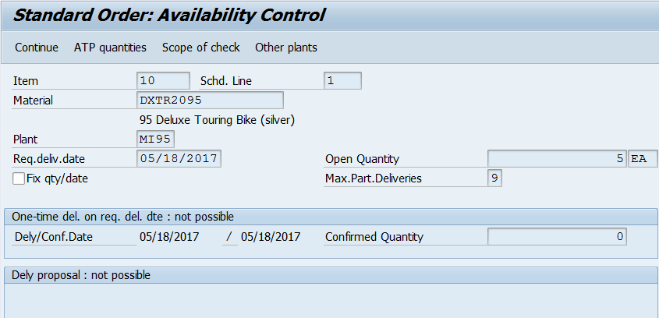

1. What is the Sales Quotation document number?  
          
2. What is the Sales Order document number?  
          
   1. Begin Procurement Process

In this section, you procure the required Trading Good and Raw Materials to fulfil the customer Purchase Order. Olympic Protective Gear is your vendor that sells Off-Road Helmets and Spy Gear is your vendor that sells all Raw Materials for your Deluxe Touring Bikes (Silver). Materials are listed in the BOM for the Deluxe Touring Bike (Silver) which is shown at the end of this document. Prices for the Purchase Order are also listed at the end of this document.

* Through this entire process, you will be using MRP (chapter 8) to produce the appropriate orders. Be careful, if you do not use the MRP Process this exercise will not be performed properly for your instructor and you will lose points.
* Note that from a Raw Materials perspective, the fact that we are procuring all Raw Materials from the same Vendor is not normal. Normally, a company would procure required materials from multiple vendors.
* DO NOT use movement type 561 (“inventory from heaven”) to acquire these materials!
* It is not necessary to create any additional product groups or an SOP for this exercise. Use the following instructions below regarding MRP.
* Use the Stock/Requirements list and create purchase requisitions for your Fifty Off-Road helmets as well as your Five Deluxe Touring Bikes (Silver). Note that the requisition for Off-Road Helmets will become a normal Purchase Order while the requisition for Deluxe Touring Bikes (Silver) will become a Stock Transport Order requesting Deluxe Touring Bikes (Silver) from Dallas.
  + 1. In the *“SAP Easy Access”* screen, follow the navigation path below:

Navigation

SAP Easy Access Menu → Logistics → Materials Management → Inventory Management → Environment → Stock → Stock/Requirements List

* + 1. In the *“Stock/Requirements List: Initial Screen”*, enter the following information:

|  |  |  |
| --- | --- | --- |
| **Attribute** | **Description** | **Data Value** |
| Material | Key uniquely identifying the material | *Your Deluxe Touring Bike (Silver)* |
| Plant | Key uniquely identifying the Plant | *Your Dallas Plant* |

* + 1. Click Continue .
    2. Double click on the first *“IndReq”* and click Change Element .
* If there are no Independent Requirements (IndReq), move on to step 3.9.
  + 1. Highlight any rows that contain data in any of the month columns and click Delete Line Item .
    2. In the *“Delete Reqmt”* pop-up, click Yes .
    3. Click Save .
    4. Click Refresh  to ensure that all the independent requirements are gone.

Off-Road Helmets

* + 1. In the *“SAP Easy Access”* screen, follow the navigation path below:

Navigation

SAP Easy Access Menu → Logistics → Production → MRP → Planning → Single-Level Single-Item Planning

* + 1. In the *“Single-Item, Single-Level”* screen, enter the following information:

|  |  |  |
| --- | --- | --- |
| **Attribute** | **Description** | **Data Value** |
| Material | Key uniquely identifying a material | *Your Off-Road Helmet* |
| Plant | Key uniquely identifying a plant | *Your DC Plant Miami* |
| Create Purchase Req. | Creation indicator for Purchase Requisition | *Planned orders* |
| Planning mode | Defines how procurement proposals from the last planning run are to be dealt with | *Delete and recreate planning data* |

* Hint: These planned orders can be converted into Purchase Requisitions later using the Stock/Requirements list.
  + 1. Click Execute.
    2. Click Enter  to dismiss the warning message *“Please check input parameters”*.
* You will receive a message that says “MRP carried out for OHMT10##”.
  + 1. In the *“SAP Easy Access”* screen, follow the navigation path below:

Navigation

SAP Easy Access Menu → Logistics → Materials Management → Inventory Management → Environment → Stock → Stock/Requirements List

* + 1. In the *“Stock/Requirements List: Initial Screen”*, enter the following information:

|  |  |  |
| --- | --- | --- |
| **Attribute** | **Description** | **Data Value** |
| Material | Key uniquely identifying the material | *Your Deluxe Touring Bike (Silver)* |
| Plant | Key uniquely identifying the Plant | *Your Dallas Plant* |

* + 1. Click Continue .
    2. Double click on your “PldOrd” .
    3. Click *“Convert Planned Order to Purchase Requisition”* .
    4. In the *“Convert Planned Order into Purch. Req.: Details”* screen in the *“Purchase Requisition Data”* section of the screen, enter the following information:

|  |  |  |
| --- | --- | --- |
| **Attribute** | **Description** | **Data Value** |
| Purchasing Group | Key for a buyer responsible for purchasing activities | *Your GBI Buyer* |

* + 1. Click Save .
* You will receive a message that says, “Planned order converted to purchase requisition”.

1. What is the Purchase Requisition document number for Off-Road Helmets?  
          
2. What is the Purchase Order document number for Off-Road Helmets?  
          

* Use the pricing chart at the end of the document for your Purchase Order.
* When you go to save the Purchase Order you will receive a warning message that says, “Requisition has different doc. type NB and item cat. ><”. Simply Click Enter  to dismiss this message to continue creating the transport order.

1. What is the Goods Receipt document number for Off-Road Helmets?  
          
2. What is the Invoice document number for Off-Road Helmets?  
          
3. What is the Accounting document number for Off-Road Helmets?  
          

Stock Transport Order

* + 1. In the *“SAP Easy Access”* screen, follow the navigation path below:

Navigation

SAP Easy Access Menu → Logistics → Production → MRP → Planning → Single-Level Single-Item Planning

* + 1. In the *“Single-Item, Single-Level”* screen, enter the following information:

|  |  |  |
| --- | --- | --- |
| **Attribute** | **Description** | **Data Value** |
| Material | Key uniquely identifying a material | *Your Deluxe Touring Bike (silver)* |
| Plant | Key uniquely identifying a plant | *Your DC Plant Miami* |
| Create purchase req. | Creation indicator for Purchase Requisition | *Purchase Requisition* |
| Planning mode | Defines how procurement proposals from the last planning run are to be dealt with | *Delete and recreate planning data* |

* + 1. Click Execute .
    2. Click Enter  to dismiss the warning message “Please check input parameters”.
* You will receive a message that says, “MRP carried out for DXTR20##”.
  + 1. Repeat Steps I.3.13 through I.3.19 for your Deluxe Touring Bike (Silver).

1. What is the Purchase Requisition document number for Deluxe Touring Bikes (Silver)?  
          
2. What is the Stock Transport Order document number for Deluxe Touring Bikes (Silver)?  
          

Raw Materials

* + 1. In the *“SAP Easy Access”* screen, follow the navigation path below:

Navigation

SAP Easy Access Menu → Logistics → Production → MRP → Planning → Multilevel Single-Item Planning

* + 1. Enter the following information:

|  |  |  |
| --- | --- | --- |
| **Attribute** | **Description** | **Data Value** |
| Material | Key uniquely identifying a material | *Your Deluxe Touring Bike (silver)* |
| Plant | Key uniquely identifying a plant | *Your Dallas Plant* |
| Create purchase req. | Creation indicator for Purchase Requisition | *Purchase Requisitions* |
| Planning mode | Defines how procurement proposals from the last planning run are to be dealt with | *Delete and recreate planning data* |

* + 1. Click Enter .
    2. Click Enter  to dismiss the warning message “Please check input parameters”.
* You will receive a message that says, “MRP carried out for DXTR20##”.

1. What is the Purchase Order document number for Raw Materials?  
          
2. What is the Goods Receipt document number for Raw Materials?  
          
3. What is the Invoice document number for Raw Materials?  
          
4. What is the Accounting document number for Raw Materials?  
          
   1. Production Process

Now that the Raw Materials are in stock, you can begin the production process. Reference Chapter 06 to help with this section.

* Check to make sure all Raw Materials are in the proper locations for production.
* Be sure that you are selecting the correct item on the stock/requirements list and the appropriate materials are going to and from the proper storage locations for production.

1. What is the Production Order document number for the Semi-Finished Product?  
          
2. What is the Goods Issue document number for the Semi-Finished Product?  
          
3. What is the Goods Receipt document number for the Semi-Finished Product?  
          
4. What is the Production Order document number for the Finished Product?  
          
5. What is the Goods Issue document number for the Finished Product?  
          
6. What is the Goods Receipt document number for the Finished Product?  
          
   1. End Procurement Process

Miami is requesting the Deluxe Touring Bike (Silver) from Dallas, to receive these Deluxe Touring Bike (Silver) into Miami you will create a Stock Transport Order. Remember, Dallas is the only plant that produces and does not distribute goods to customers, so we must send the Deluxe Touring Bikes (Silver) to Miami to fulfil the Sales Order. Recall from Chapter 07 on how to make a Stock Transport Order.

1. What is the Goods Issue document number for the Stock Transport Order?  
          
2. What is the Goods Receipt document number for the Stock Transport Order?  
          
   1. End Fulfillment Process

In this section, you end the fulfilment process by sending shipment and Invoice to your customer.

To tell the system that you now have sufficient inventory to fulfil the Purchase Order sent by your customer, it is highly advised to go back to your Sales Order to note the required delivery date you have entered and to make sure that multiple schedule lines disappear for all your materials. This is done in “Availability Check”. But if you already have inventory the ATP check will not be displayed. “Availability Check” will only appear if you have no inventory.

* + 1. In the *“SAP Easy Access”* screen, follow the navigation path below:

Navigation

SAP Easy Access Menu → Logistics → Sales and Distribution → Sales → Order → Change

* + 1. In the *“Change Sales Document: Initial Screen”* screen, enter the following information:

|  |  |  |
| --- | --- | --- |
| **Attribute** | **Description** | **Data Value** |
| Order | Uniquely identifies the sales document | *Your Sales Order Number* |

* + 1. Click Continue .
    2. In the *“Change Standard Order: Overview”* screen, click Select All  at the bottom of the screen.
    3. Click Check Item Availability .
    4. In the *“Standard Order: Availability Control”* screen, click Complete dlv.
* You will receive a message that says, “Availability check was carried out”.
* You are performing this for both materials.
  + 1. Click Complete dlv.
* You will receive a message that says, “Availability check was carried out”.
  + 1. In the *“Change Sales Order: Overview”* screen, click Save .
* You will receive a message that says, “Standard Order has been saved”.
* This will now allow you to create the Outbound Delivery with reference to your Sales Order.

1. What is the Outbound Delivery document number?  
          
2. What is the Invoice document number?  
          
3. What is the Accounting document number?  
          

1. Exercise Deliverables

**Name:**

**Course and Section:**

**Identifier:**

**Client:**

1. What is the Sales Quotation document number?  
    
2. What is the Sales Order document number?  
    
3. What is the Purchase Requisition document number for Off-Road Helmets?  
    
4. What is the Purchase Order document number for Off-Road Helmets?  
    
5. What is the Goods Receipt document number for Off-Road Helmets?  
    
6. What is the Invoice document number for Off-Road Helmets?  
    
7. What is the Accounting document number for Off-Road Helmets?  
    
8. What is the Purchase Requisition document number for Deluxe Touring Bikes (Silver)?  
    
9. What is the Stock Transport Order document number for Your Deluxe Touring Bikes (Silver)?  
    
10. What is the Purchase Order document number for Raw Materials?  
     
11. What is the Goods Receipt document number for Raw Materials?  
     
12. What is the Invoice document number for Raw Materials?  
     
13. What is the Accounting document number for Raw Materials?  
     
14. What is the Production Order document number for the Semi-Finished Product?  
     
15. What is the Goods Issue document number for the Semi-Finished Product?  
     
16. What is the Goods Receipt document number for the Semi-Finished Product?  
     
17. What is the Production Order document number for the Finished Product?  
     
18. What is the Goods Issue document number for the Finished Product?  
     
19. What is the Goods Receipt document number for the Finished Product?  
     
20. What is the Goods Issue document number for the Stock Transport Order?  
     
21. What is the Goods Receipt document number for the Stock Transport Order?  
     
22. What is the Outbound Delivery document number?  
     
23. What is the Invoice document number?  
     
24. What is the Accounting document number?  
     

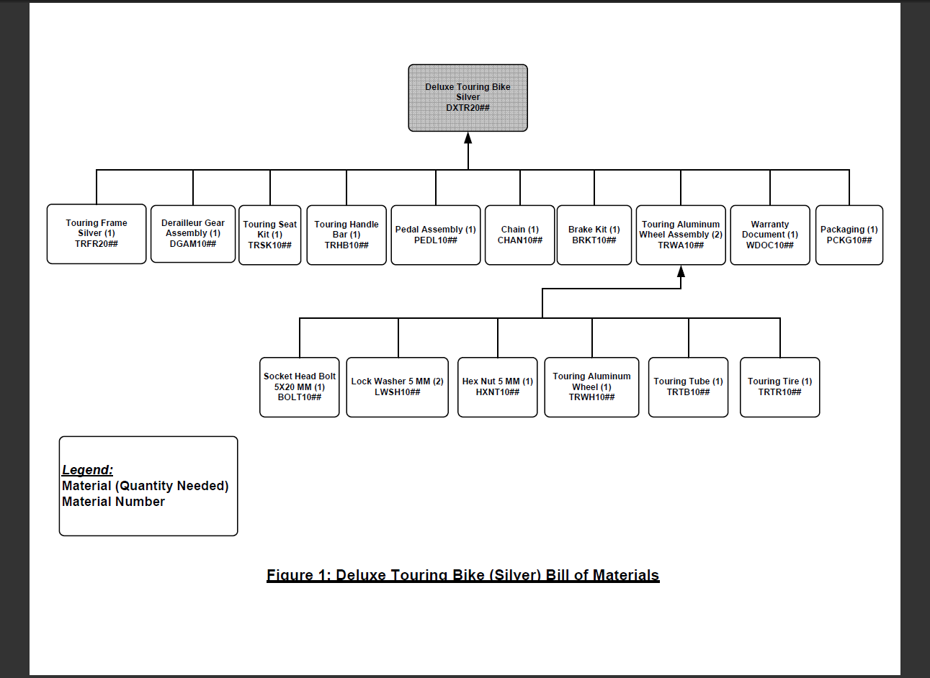

|  |  |
| --- | --- |
| **Description** | **Net Purchasing Price** |
| Off-Road Helmet | $25.00 |
| Socket Head Bolt 5x20mm | $0.10 |
| Lock Washer 5 mm | $0.05 |
| Hex Nut 5 mm | $0.10 |
| Touring Aluminium Wheel | $95.00 |
| Touring Tube | $5.00 |
| Touring Tire | $10.00 |
| Touring Frame-Silver | $200.00 |
| Derailleur Gear Assembly | $75.00 |
| Touring Seat Kit | $50.00 |
| Touring Handle Bar | $25.00 |
| Pedal Assembly | $45.00 |
| Chain | $10.00 |
| Brake Kit | $70.00 |
| Warranty Document | $1.00 |
| Packaging | $3.50 |